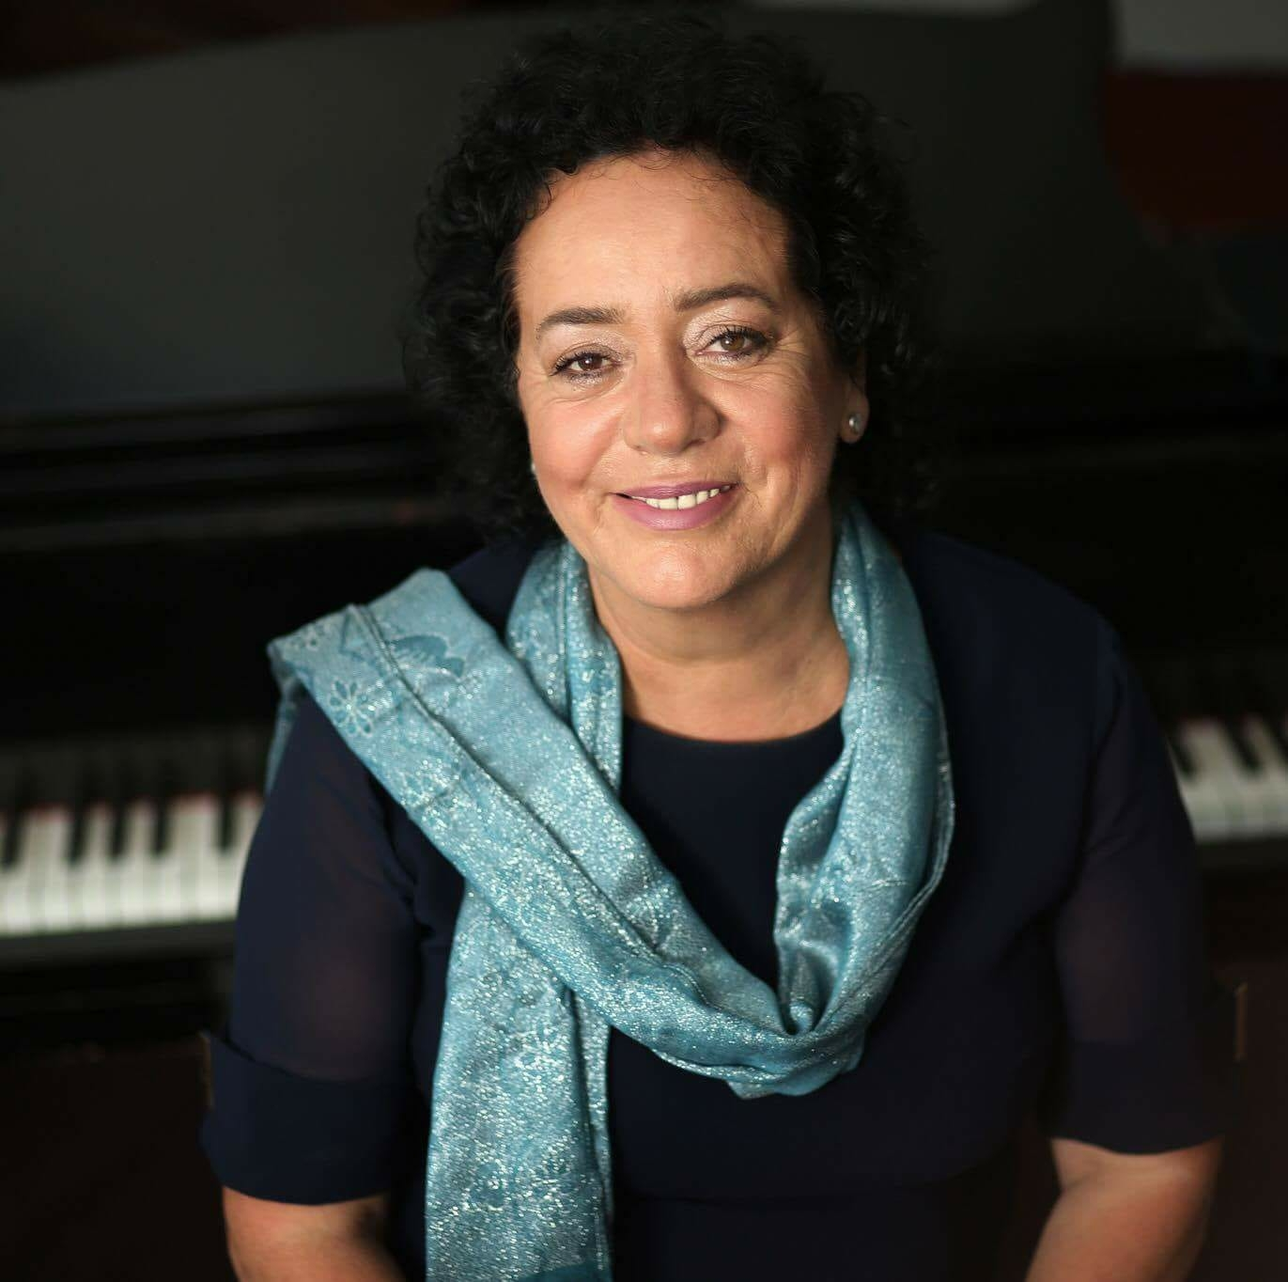
CURRICULUM VITAE

1. Family Name: | Pula – Petrovci
2. First Name: | Valbona
3. Nationality: | Albanian
4. Date of Birth | 03.07.1958
5. Gender: | F
6. Contact details:
Email: |  | valbonapetrovci@hotmail.com  valbonapetrovci@gmail.com
Tel: |  | +383 49 161 724 ; + 383 44 161724
7. Education Degree:
Institution: |  | Faculty of Arts, Department of Music – Brach PIANO, class of E. Korolov and I. Dimecevka
Degree Date: |  | 30.09.1980
Degree : |  | Graduated pianist
Institution: |  | Post graduation studies, PIANO branch, class of Prof. Ord. Jasmina Cakar in Skopje (Macedonia)
Degree Date: |  | 09.03.2001
Degree/ Master : |  | Magister of Piano
Institution:
Degree Date:
Degree / Doctorate :
8. Academic Degree:
Institution: |  | University of Pristina
Degree Date: |  | Ordinary professor
Other publications
Public appearences
1979 – J.S.Bach: Concert for piano and orchestra F – mol
1980 – L.V.Beethoven: Concert for piano and orchestra no.1 in C – dur, Budva Monte Negro

 |  | 1980 – Piano recital in Radio Television of Pristina
 |  | 1981 – Soloist in “ Days of Music” – Gjakova (Kosovo)
 |  | 1981 – Soloist in “ Music Tribune” – Opatija (Slovenia)
 |  | 1982 – Soloist in musical meetings “Abrasevic” – Valjevo (Serbia), Winner of reward of Novi Sad
 |  | 1983 – Piano recital, Prizren (Kosovo)
 |  | 1984 – Soloist, Albanian Composers, Skopje (Macedonia)
 |  | 1985 – Evening Concert with flute and piano, Novi Sad (Serbia)
 |  | 1986 - Evening Concert with flute and piano, Sarajevo (Bosnia)
 |  | 1988 – Soloist in “ Days of culture of Kosovo” Dubrovnik ( Croatia
 |  | 1989 – F.Liszt Concert for piano and orchestra A – dur, Pristina (Kosovo)
 |  | 1992 - Soloist in “ Days of culture of Kosovo” Tirana (Albania)
 |  | 1995 – Piano soloist in Summer Festival of Ulcinj – Ulcinj (Monte Negro)
 |  | 1996 - Evening Concert with flute and piano in Summer Festival of Ulcinj – Ulcinj (Monte Negro)
 |  | 1997 - Piano recital, Mitrovica (Kosovo)
 |  | 1997 - Piano recital, Gjakova ( Kosovo)
 |  | 1997 - Piano recital, Prizren (Kosovo)
 |  | 1997 - Piano recital, Pristina (Kosovo)
 |  | 1998 - Piano recital, Skopje (Macedonia)
 |  | 1998 - D.Shotakoviq: Concert for piano and orchestra no.2 in F – dur, played with two pianos, Skopje (Macedonia)
 |  | 1999 – J.S. Bach: Concert for piano and orchestra in F- mol in Festival “Artists for peace, tolerance and democracy” Pristina (Kosovo)
 |  | 2000 – Soloist in the New Year concert dedicated to the KFOR – forces, Pristina (Kosovo)
 |  | 2000 – Participating in chamber ensemble in international festival “ Bach Week”
 |  | 2000 – Accompanying in piano in “International Festival of Chamber Music” Pristina (Kosovo)
 |  | 2001 – Piano recital, Skopje (Macedonia)
 |  | 2001 - Accompanying in piano in “International Festival of Chamber Music” Pristina (Kosovo)
 |  | 2004 – Member of the Jury in international competition “EPTA” Tirana (Albania)
 |  | 2006 - Member of the Jury in international competition “ARS – Kosova” Pristina (Kosovo)
 |  | 2008 - Member of the Jury in piano competition “Bell – Arte” Mitrovica (Kosovo)
 |  | 2016 - Member of the Jury in international competition “ARS – Kosova” Pristina (Kosovo)
10. Work experience record:
Dates: |  | 1980 – 1981
Location: |  | Pristina
Name of the Institution: |  | High Music School “Prenk Jakova”
Position: |  | Professor of piano
Dates: |  | 1981 – 1991,
Location: |  | Pristina
Name of the Institution: |  | Faculty of Arts, Music Departament
Position: |  | professor of piano obligato
Dates: |  | 1991 – present
Location: |  | Pristina
Name of the Institution: |  | Faculty of Arts, Music Departament, PIANO brach,
Position: |  | professor of PIANO
Dates: |  | 1999- 2002
Location: |  | Pristina
Name of the Institution: |  | “Association of Music Artists in Kosovo”
Position: |  | President
Dates: |  | 2001 – Main organizer of Pristina (Kosovo)
Location: |  | Pristina
Name of the Institution: |  | “International Festival of Chamber Music”
Position: |  | Main organizer
Dates: |  | 2002
Location: |  | Pristina
Name of the Institution: |  | Music School “ Amadeus”
Position: |  | Founder and professor of piano
Dates: |  | 2007 – 2014
Location: |  | Prishtina
Name of the Institution: |  | AAB – University Department of Music,
Position: |  | Professor of piano obligato
Dates: |  | 2009 – 2012
Location: |  | Pristina
Name of the Institution: |  | Faculty of Arts, Music Department, University of Pristina
Position: |  | Vice Dean
Date |  | 2017
Location |  | Pristina
Name of the Institution |  | The Municipal Assembly of Pristina
Position |  | Member in the assembly of Pristina
Date |  | 2017-2020
Location |  | Pristina
Name of the Institution |  | Faculty of Arts
Position |  | Chief of the Master-Performance Program
11. Education and training:

Dates: |  | 1982
Title of qualification awarded:
Principal subjects/occupational skills covered: |  | Summer intensive Piano course class of J.C.Vanden Eynden
Name and type of institution providing education and training: |  | Ministry of Culture in Libramont (Belgium),
Level of national and international classification:
Dates: |  | 1983 -
Title of qualification awarded:
Principal subjects/occupational skills covered: |  | Summer intensive Piano course class of Jean Marie Darre
Name and type of institution providing education and training: |  | Ministry of Culture in Nice (France)
Level of national and international classification:
Dates: |  | 2001-
Title of qualification awarded:
Principal subjects/occupational skills covered: |  | Participating in multi – ethnic artistic project
Name and type of institution providing education and training: |  | organized by the Norwegian government
Level of national and international classification:
Language skills: (1 to 5: 1 lowest - 5 fluent)
Language. | Speaking |  | Writing | Reading
Albanian | 5 |  | 5 | 5
Serbian | 5 |  | 5 | 5
English | 5 |  | 5 | 5
Awards and Membership:

